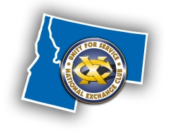
YELLOWSTONE DISTRICT EXCHANGE CLUBS
2017 DISTRICT CONVENTION REGISTRATION FORM

WHEN: April 28 – 29, 2017 (Friday & Saturday)
WHERE: DoubleTree Inn by Hilton, 27 N. 27th St., Billings, MT 59101 – In Downtown Billings

HOTEL REGISTRATION:
A block of rooms is reserved at a rate of $119 per night plus tax (standard double queens). Ask for Yellowstone District Exchange Clubs Block. Tel: 406-252-7400. Cutoff Date is March 28, 2017.

An additional block of rooms is being held at The Clock Tower Inn (406-259-5511), which is located 1 block away from our host hotel. The rate is $115 per night plus tax. With this option, you do get a Free breakfast at Stella’s next door. Voted the best Breakfast in Billings for the past 11 years. Cut off is April 7, 2017.

CONVENTION REGISTRATION:
This year one club member from each club is entitled to a waived convention full registration package, as long as the club is in good standing with the District and National Exchange.

FULL REGISTRATION PACKAGE: (includes registration fee and meals)
Package at $150 x |  | = $ |  | (if paid by April 15, 2017; $160 thereafter)
Waived Package |  | (contact your club for approval)

PROGRAM GUESTS Include: National Exchange Club President – Elizabeth Grantham and Foundation
Chairman Ray Carlson.

INDIVIDUAL COSTS (AL A CARTE):
Convention Registration Fee: | Qty: |  | x | $60 | = | $
Friday Night Dinner and Entertainment:  Featuring Projectile Comedy | Qty: |  | x | $30 | = | $
Saturday Breakfast: | Qty: |  | x | $15 | = | $
Saturday Lunch: | Qty: |  | x | $20 | = | $
Saturday Awards Dinner Banquet: | Qty: |  | x | $35 | = | $
 | TOTAL COST: |  |  |  |  | $
No refunds on cancellations after Friday, April 21, 2017
Member Name: |  | Club:
Current Status: Member Pres Pres Elect VP Treasurer Secy First-time attendee? Y or N
Spouse/Guest Name: |  | Children Attending:

PAYMENT: Please make checks payable to “Yellowstone District Exchange” and forward with this form to:
Yellowstone District Treasurer c/o Lisa Mee, 310 Elm Street, Idaho Falls, ID 83402
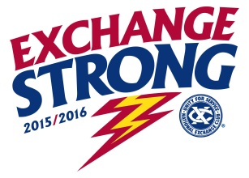
QUESTIONS: David Weller, District President, (406) 671-0703 or dweller3703@gmail.com
Leif Welhaven, District President Elect, (406) 698-5014 or leif@eecmt.com

